**Phase 2: Org Setup & Configuration**

**Step 1: Salesforce Edition**

* Go to developer.salesforce.com.
* Sign up for a **Free Developer Org** (you’ll receive login via email).
* Log in and confirm the **Lightning Experience** is enabled.
* 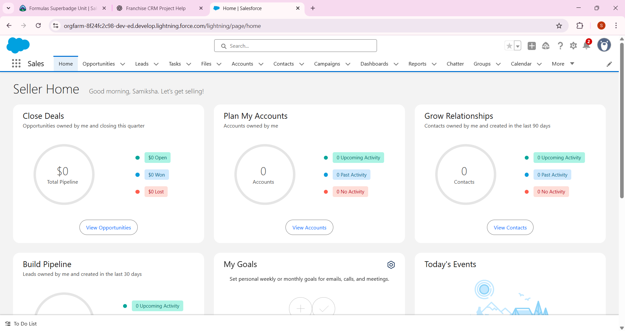

## Step 2: Company Profile Setup

* Click **⚙️ Setup (gear icon)** → **Company Information**.
* Edit:
  + Company Name: Franchise Management CRM Pvt Ltd
  + Local Time Zone: Asia/Kolkata (IST)
  + Currency: INR (or USD).
* Save changes.

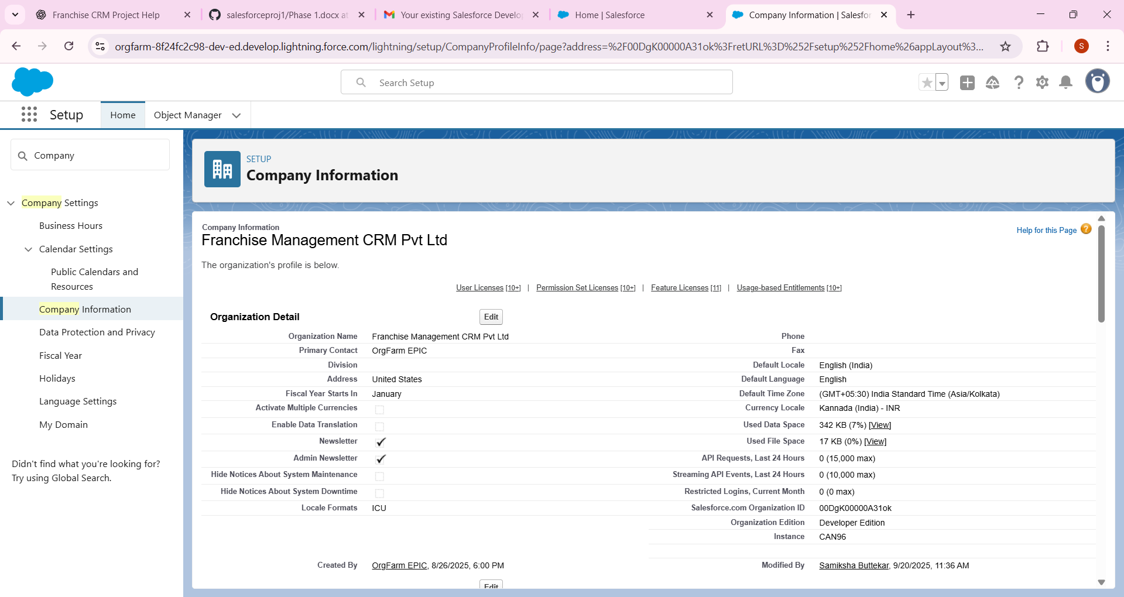

## Step 3: Business Hours & Holidays

* In Setup → Search **Business Hours**.
* Create new Business Hours:
  + Name: Franchise CRM Business Hours
  + Hours: 9:00 AM – 6:00 PM
* In Setup → Search **Holidays**.
* Add at least 2 holidays (e.g., Republic Day 26-Jan, Diwali date).
* Locale → English (India)
* Time Zone → Asia/Kolkata
* Currency → INR

**Steps to Add Holidays in Salesforce**

1. Go to **Setup** (⚙️ → Setup).
2. In **Quick Find**, type **Holidays** → click **Holidays** under *Company Settings*.
3. Click **New Holiday**.
4. Fill in the details:
   * **Holiday Name:** e.g., *Diwali 2025*
   * **Date:** select the holiday date
   * **All-Day Event:** ✅ check this (so it covers the full day)
   * **Recurring Holiday:** (optional) → for holidays like *Independence Day (15th Aug)* that repeat every year.
5. Click **Save**.

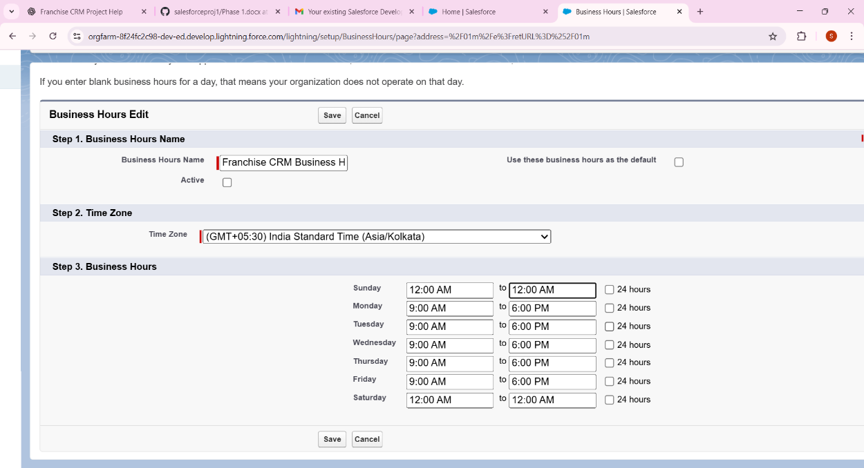

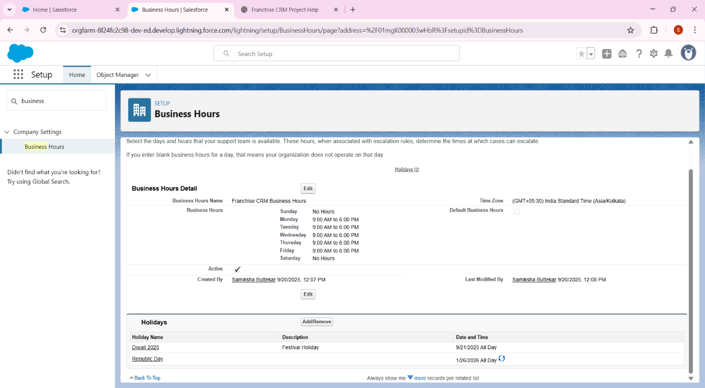

**Step 4: Fiscal Year Settings**

* In Setup → Search **Fiscal Year**.
* Keep **Standard (Jan–Dec)** selected.

### Options You See

1. **Standard Fiscal Year** → default option, runs Jan–Dec.
   * Start month: January
   * Fiscal year name: based on ending month (so 2025 fiscal year means Jan–Dec 2025).
   * ✅ Recommended for your project (simple, no errors).
2. **Custom Fiscal Year** → used if the company runs on Apr–Mar (like Indian financial year) or other variations.
   * More complex, requires enabling custom fiscal years.

**Step 5: User Setup & Licenses**

* In Setup → Search **Users**.
* Click **New User**. Create:
  1. *Outlet Manager* – License: Salesforce, Profile: Standard User.
  2. *Franchise Owner* – License: Salesforce, Profile: System Administrator (if needed).

### **Step-by-Step for Creating “Outlet Manager” User**

1. **First Name:**  
   👉 Outlet
2. **Last Name (Required):**  
   👉 Manager
3. **Role:**  
   👉 Leave it <None Specified> for now (we’ll assign roles later in the hierarchy setup).
4. **User License (Required):**  
   👉 Select Salesforce
5. **Alias (auto-fills usually):**  
   👉 Keep as suggested (e.g., outletm).
6. **Profile (Required):**  
   👉 Choose Standard User (sufficient for Outlet Manager access).
7. **Email (Required):**  
   👉 Use your own email (e.g., outletmanager.yourname@gmail.com) so that Salesforce sends the activation email to you.
8. **Active:**  
   👉 Keep it **checked** ✅
9. **Username (Required):**  
   👉 Must be unique across all Salesforce orgs. Format like an email. Example:  
   outletmanager.crmproject2025@gmail.com  
   (⚠️ It doesn’t have to be a real Gmail, just a unique email-style format. But easier if you use your own Gmail.)
10. **Nickname:**  
    👉 Auto-fills (keep as it is)
11. **Other Checkboxes:**
12. **Marketing User:** Leave unchecked (not needed).
13. **Offline User / Knowledge User / Service Cloud User:** Leave unchecked.
14. **Flow User:** ✅ Keep checked (needed if this user will run automation/flows).
15. **Company / Department / Division:**  
    👉 Optional – you can leave blank for now.
16. **Save.**

* 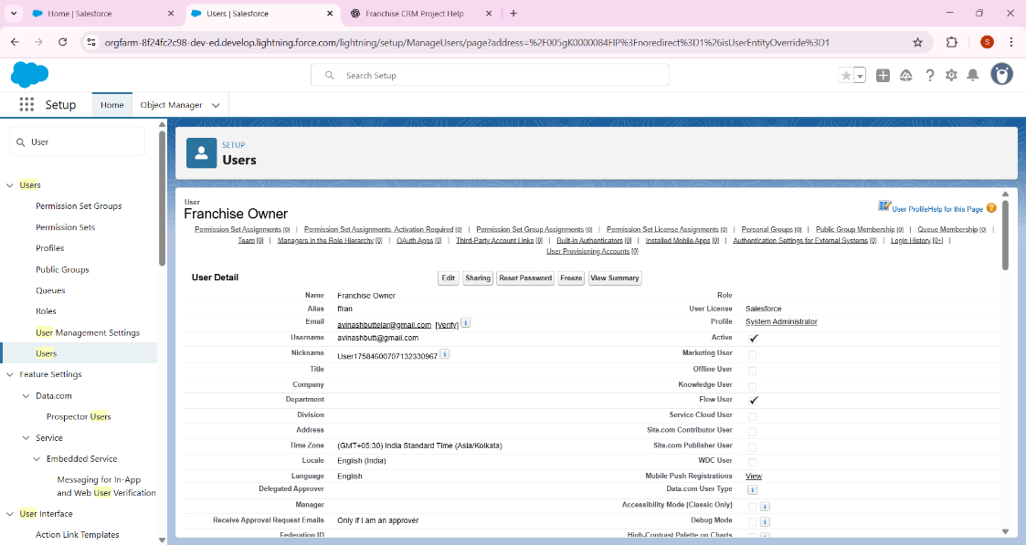

**Step 6: Profiles**

* In Setup → Search **Profiles**.
* Clone **Standard User** → Name it *Outlet Manager Profile*.
  + Permissions: Can create & edit **Outlets, Sales Records, Compliance Records**.
* For **Franchise Owner Profile** → Give full access.

### Step 1: G to Profiles

1. Click the ⚙️ **Setup (gear icon)** → **Setup**.
2. In Quick Find → search **Profiles**.
3. You’ll see the list of profiles (like in your screenshot).

### 🔹 Step 2: Open a Profile

1. Click on the **Profile Name** (example: Standard User, or your cloned Outlet Manager Profile).  
   ⚠️ Don’t click Edit | Clone on the right — instead click the **blue link of the profile name itself**.

### 🔹 Step 3: Find Object Settings

Now you’re on the **Profile Detail page**.  
Scroll down — you’ll see different sections like:

* Administrative Permissions
* App Permissions
* **Object Settings** ✅ (this is the one we need)

Click **Object Settings**, and you’ll get a list of objects (Accounts, Contacts, etc.).

### 🔹 Step 4: Edit Object Access

1. Click on the object name (example: Account).
2. Click **Edit**.
3. Select which permissions you want to allow:
   * Read
   * Create
   * Edit
   * Delete
   * View All / Modify All (for Franchise Owner profile).
4. Save.

If you **still don’t see Object Settings** inside the Profile page → it means your org may be showing the **“Enhanced Profile User Interface”** instead of the old one. In that case:

* Go to **Setup** → search **User Management Settings**.
* Check if **Enhanced Profile User Interface** is enabled.
* If yes, then Object Settings appear as **“Object Permissions”** inside the profile page.

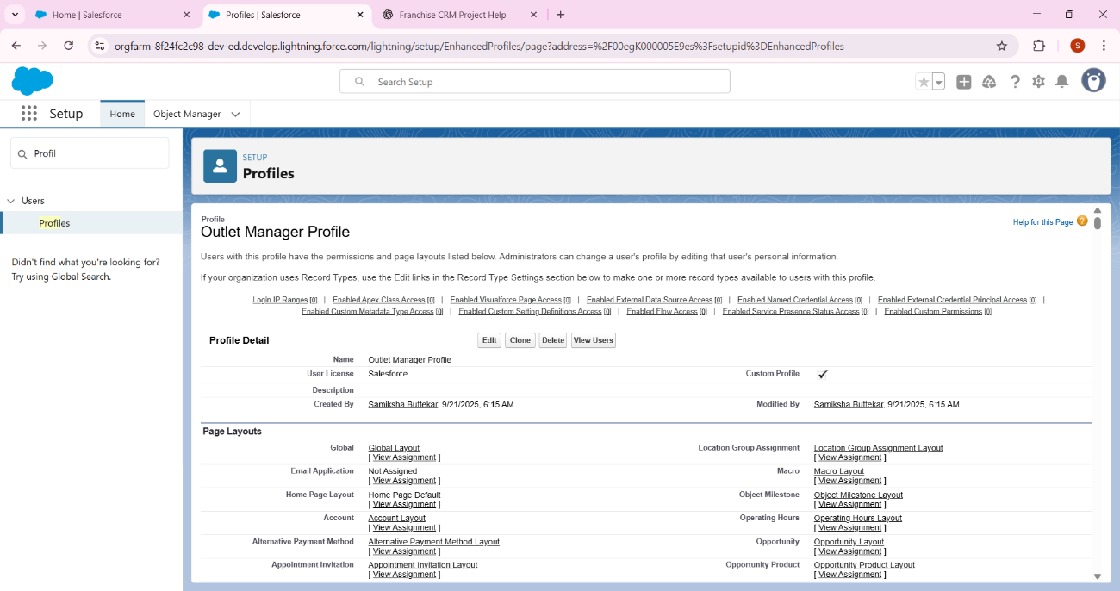

**Step 7: Roles**

* In Setup → Search **Roles** → **Set Up Roles**.
* Create:
  + *Franchise Owner (top role)*
  + *Outlet Manager (child role)*
* Assign Outlet Managers to lower role.

**1: Go to Roles Setup**

1. In Salesforce, click the **⚙️ gear icon → Setup**.
2. In the **Quick Find box**, type **Roles**.
3. Select **Roles → Set Up Roles**.
   * You’ll now see a **role hierarchy page** with “CEO” at the top (default starting point).

**2: Create the Franchise Owner Role**

1. On the role hierarchy page, click the **Add Role** button (beside CEO).
2. Fill in details:
   * **Label:** Franchise Owner
   * **Role Name:** Franchise Owner
   * **Parent Role:** CEO (this will put Franchise Owner directly under CEO).
   * Leave the rest as default.
3. Click **Save**.

**3: Create the Outlet Manager Role**

1. Back on the role hierarchy page → find **Franchise Owner**.
2. Click **Add Role** under Franchise Owner.
3. Fill in details:
   * **Label:** Outlet Manager
   * **Role Name:** Outlet Manager
   * **Parent Role:** Franchise Owner
4. Save.

**4: Assign Users to Roles**

1. On the role hierarchy page → click the **“Assign” link** beside *Outlet Manager*.
2. From the available users list → select your **Outlet Manager user** and assign.
3. Do the same for **Franchise Owner role** → assign your “Franchise Owner” user.

**5: Verify Role Hierarchy**

* You should now see:

CEO

↳ Franchise Owner

↳ Outlet Manager

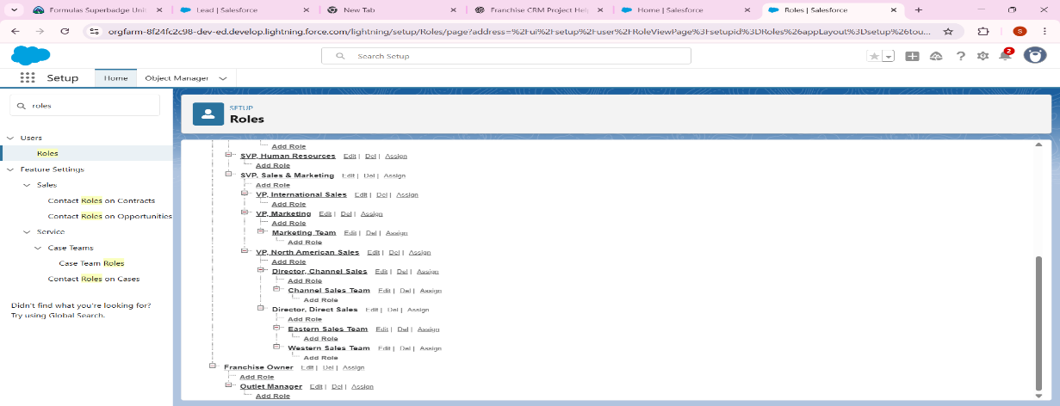

## Step 8: Permission Sets

* In Setup → Search **Permission Sets** → **New**.
* Name: Reports Access.
* Add extra access to Reports & Dashboards.
* Assign to Outlet Manager if needed.

**1: Create the Permission Set**

On the screen you shared:

1. **Label:** Reports Access  
   (API Name will auto-fill as Reports_Access).
2. **Description (optional):** Extra access to Reports & Dashboards.
3. **License:** keep as --None-- (because we want flexibility to assign this permission set to any user, regardless of their license).
4. Click **Save**.

**2: Add Report & Dashboard Permissions**

After saving, you’ll land on the **Permission Set Overview Page**.

1. Scroll down to the section **System Permissions**.
2. Click **System Permissions → Edit**.
3. Tick these checkboxes:
   * Run Reports
   * Create and Customize Reports
   * View Dashboards in Public Folders
   * Create and Customize Dashboards (optional, if you want managers to make dashboards)
4. Click **Save**.

**3: Assign the Permission Set**

1. On the permission set page, click **Manage Assignments**.
2. Click **Add Assignments**.
3. Select your **Outlet Manager** user(s).
4. Click **Assign** → Done.

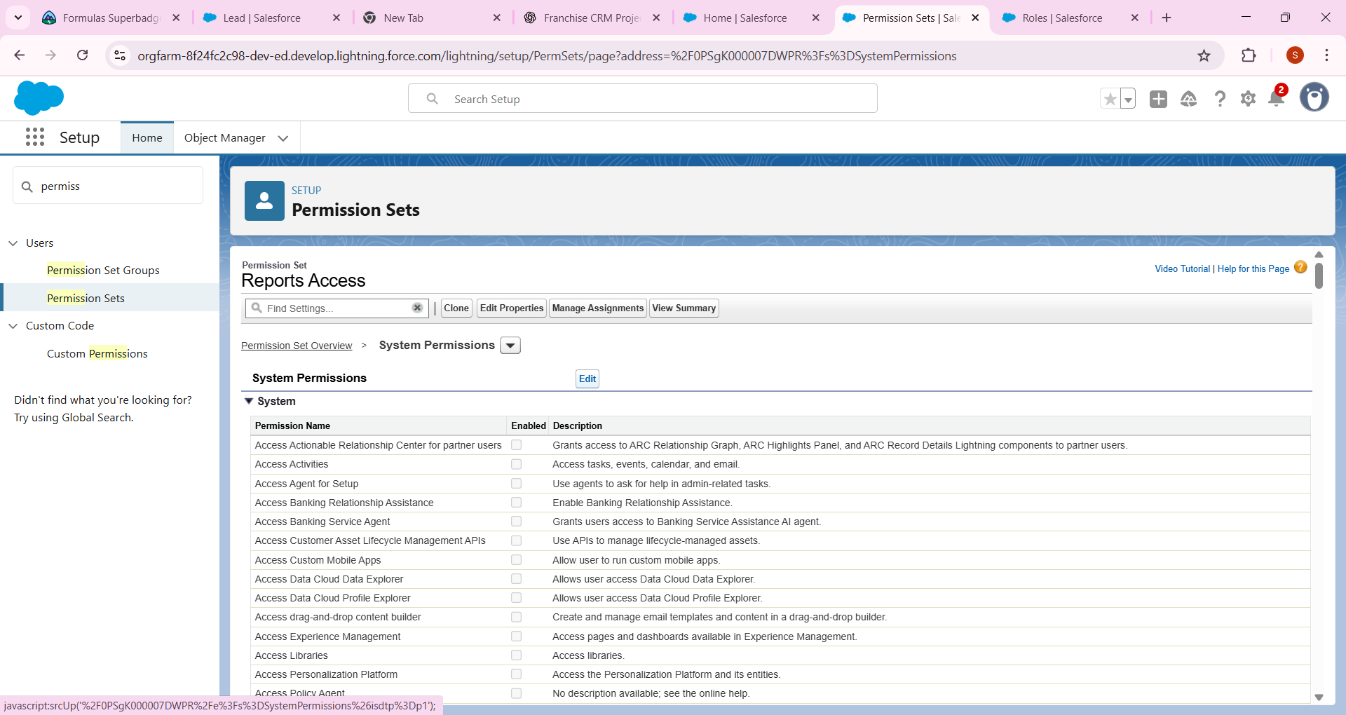

## Step 9: Org-Wide Defaults (OWD)

* In Setup → Search **Sharing Settings**.
* Change:
  + **Outlets** → Public Read Only.
  + **Sales Records** → Private.
  + **Compliance Records** → Private.

**1: Open OWD**

You already did this ✅ (Setup → Search → **Sharing Settings** → Organization-Wide Defaults).

**2: Find Your Objects**

Scroll in the **Object column** until you locate the objects you need to adjust. In your case, the instructions say:

* **Outlets → Public Read Only**
* **Sales Records → Private**
* (Compliance Records → Private as per your notes)

These are the custome object

* **Outlets__c**
* **Sales_Records__c**
* **Compliance_Records__c**

**3: Change Defaults**

For each custom object:

1. Click **Edit** (at the top of the OWD table).
2. In the **Default Internal Access** column:
   * Set **Outlets__c → Public Read Only**
   * Set **Sales_Records__c → Private**
   * Set **Compliance_Records__c → Private**
3. Leave **Grant Access Using Hierarchies** checked (unless instructed otherwise).
4. Save.

**4: Verify**

After saving, scroll back to the OWD list and confirm that:

* Outlets = Public Read Only
* Sales Records = Private
* Compliance Records = Private

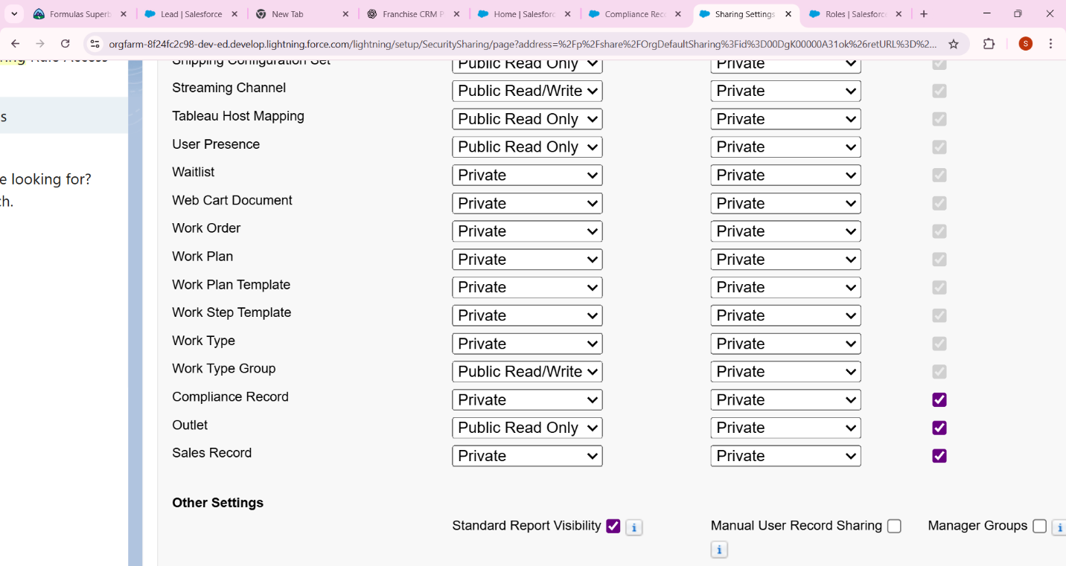

## Step 10: Sharing Rules

* In Setup → **Sharing Settings** → Create Sharing Rule.
* Example: Share **Sales Records** with all Outlet Managers.

## 1: Go to the right object’s section

Scroll down until you see **Sales Record Sharing Rules** (you already showed me it’s listed with “No sharing rules specified”). ✅

## 2: Create a New Sharing Rule

## In the **Sales Record Sharing Rules** section → click **New**.

You will see a form to define the sharing rule.

## 3: Fill in Sharing Rule Details

Example:

* **Label:** Share Sales Records with Outlet Managers
* **Rule Name (API):** Share_Sales_Records_Outlet_Managers (auto fills)
* **Rule Type:**
  + If you want to share **based on record ownership**, select **Based on record owner**.
  + If you want to share **all Sales Records that meet certain criteria**, choose **Based on criteria**.  
    👉 In your case, usually “Based on record owner” is simplest.

## 4: Configure Rule Access

* **Share Records Owned By:** (e.g., Franchise Owner, or All Users in Role Franchise Owner – depends on your hierarchy)
* **With:** Role = **Outlet Manager**
* **Access Level:** Read/Write (so they can edit Sales Records).

## 5: Save & Recalculate

* Click **Save**.
* Salesforce may ask you to **Recalculate Sharing** – confirm Yes.

## 6: Verify

After saving, in the **Sales Record Sharing Rules** section, you should now see your new rule listed.

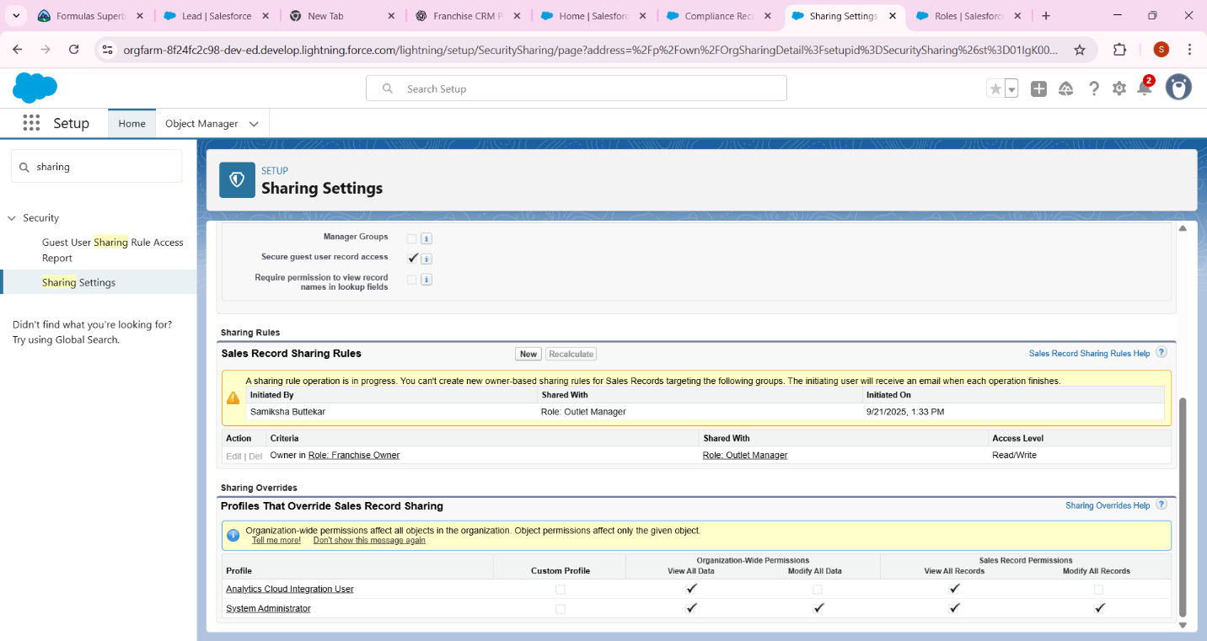

## Step 11: Login Access Policies

* In Setup → Search **Profiles** → Edit Outlet Manager Profile.
* Restrict Login Hours → 9 AM – 6 PM.

## Step-by-Step: Restrict Login Hours for Outlet Manager Profile

1. **Go to Setup**
   * In the **Quick Find** search box, type **Profiles**.
   * Click **Profiles**.
2. **Select the Profile**
   * Find the **Outlet Manager Profile** (the one you created earlier).
   * Click **Edit**.
3. **Scroll to Login Hours**
   * In the profile settings page, scroll down until you find a section called **Login Hours**.
   * By default, it may be “None” (meaning unrestricted).
4. **Set Hours**
   * You’ll see a table with **Days of the Week** and **Start Time – End Time**.
   * For **Monday → Sunday**, set:
     + **Start Time:** 9:00 AM
     + **End Time:** 6:00 PM
   * Leave it blank (None) if you want to block access entirely on certain days.

⚡ Example:

| **Day** | **Start Time** | **End Time** |
| --- | --- | --- |
| Monday | 9:00 AM | 6:00 PM |
| Tuesday | 9:00 AM | 6:00 PM |
| … | … | … |
| Sunday | 9:00 AM | 6:00 PM |

1. **Save**
   * Click **Save** at the bottom.

✅ Result: Now Outlet Managers **cannot log in before 9 AM or after 6 PM**. If they try, Salesforce will show them a **Login Hours Restriction error**.

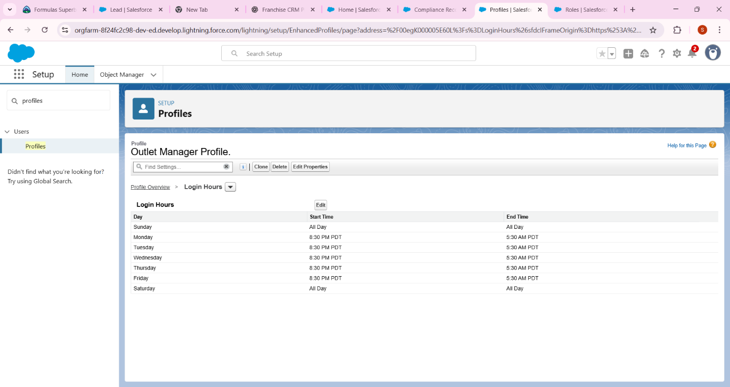

## Step 12: Developer Org Setup (Sandbox Concept)

* Note: Developer Edition **acts as sandbox** for your project.
* In real companies: Build in Sandbox → Deploy to Production.

**Understanding the Concept**

* In **real companies**, people don’t build directly in **Production Org** (the live system used by customers).
* They use a **Sandbox** (a copy of Production) or a **Developer Org** (like the free one you’re using) for **safe development & testing**.
* Once tested, changes are **deployed** to Production.

For your project:

* Your **Developer Edition Org** (the one you signed up with) **acts as a Sandbox**.
* That’s why you don’t need to create a separate Sandbox.

**What You Need to Do for This Step**

1. **Go to Setup Home**
   * Click the **gear icon** (⚙️) → **Setup**.
2. **Check the Org Name**
   * At the **top of the Setup Home page**, you’ll see something like:  
     Franchise Management CRM Pvt Ltd (Developer Edition)
   * The words **Developer Edition** confirm this is already your sandbox-like environment.
3. **Take a Screenshot**
   * The screenshot should clearly show:
     + Your **Org Name** (e.g., Franchise Management CRM Pvt Ltd).
     + The text **Developer Edition**.
   * This is the proof for Step 12.

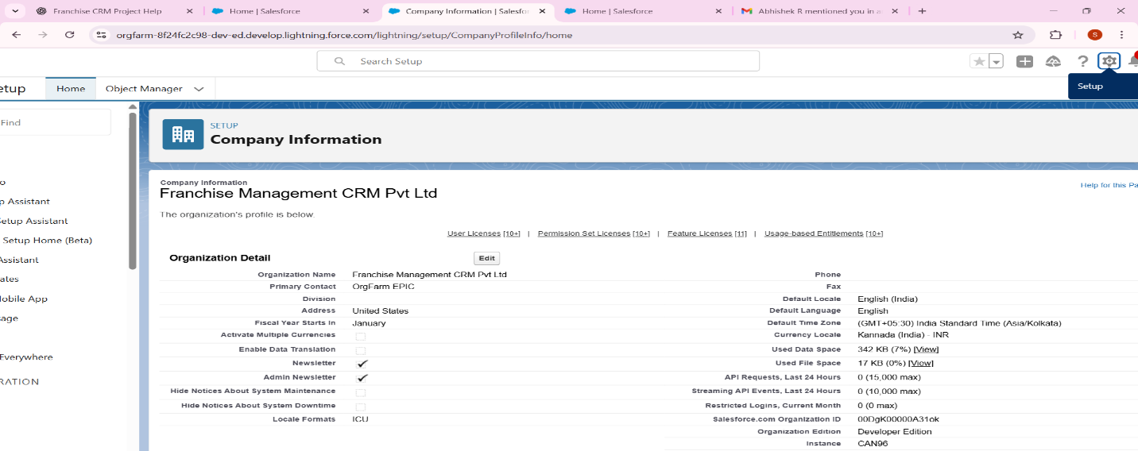

## Step 13: Deployment Basics

* Mention in report: Deployment is done using **Change Sets** or **Salesforce CLI**.
* No action needed in free Dev Org, just theory.